A000-Asia-Nepal-Shaman-Mask- **Early 1900’s**

**Case no. 15**

**AUTHENTIC GUARANTEED NEPAL SHAMAN’S MASK, METAL EYES AND TEETH, HAIR.  ABOUT 14" , YEARS OF RITUAL USE-USED IN RITUALS CORRECT PATINA RICH FROM YEARS OF USE, VERY WORN FROM USE. Early 1900’s**

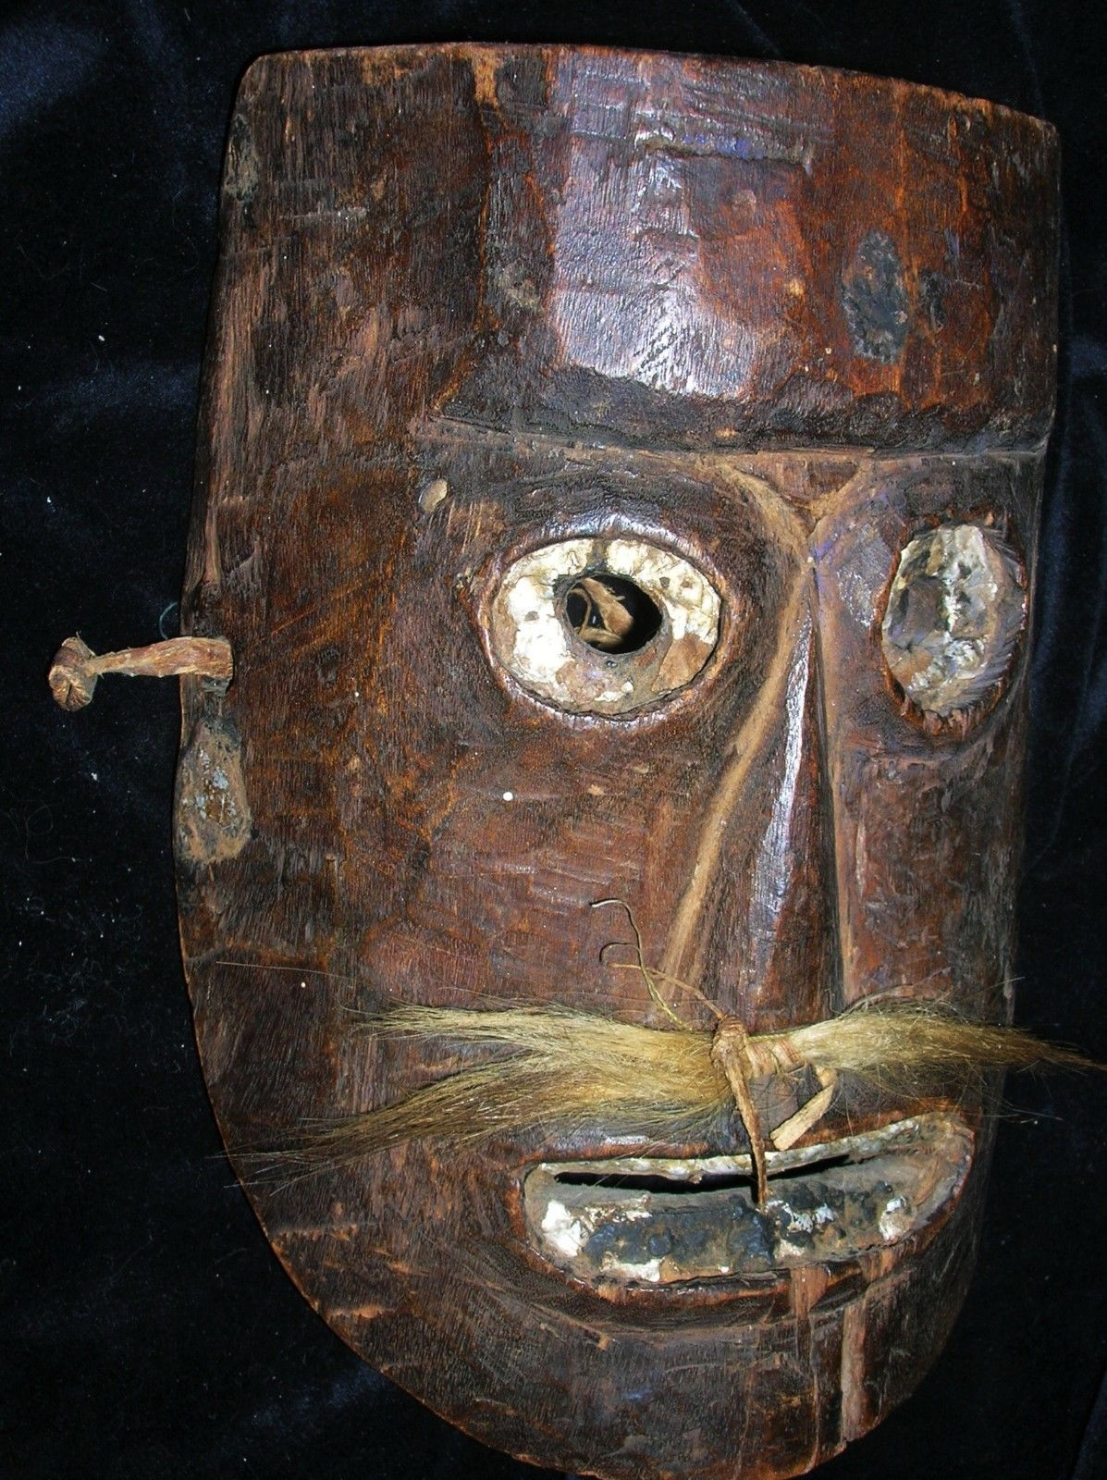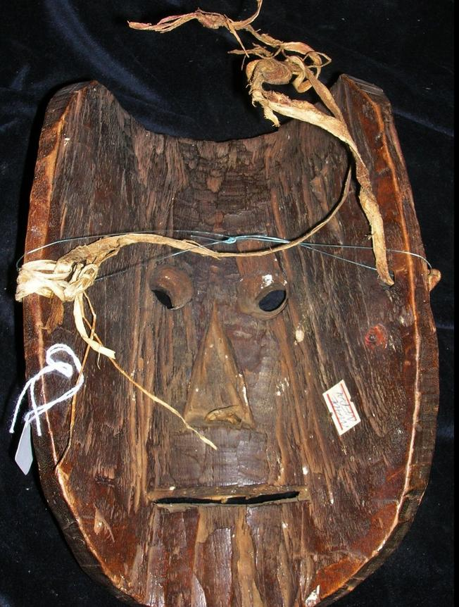

# NEPAL SHAMAN’S PHURBA 10" EARLY 1900’s